José Armando Melchor Soto
ITESO
Stock Market Risk Analysis
Credit Models

Table of Contents
Altman Z-Score 2
Source 3
Implementation 3
Results 4
Interpretation 5
Merton Model 6
Source 6
Implementation 7
Results 7
Interpretation 8
Credit Decision 9
Bibliography 10

Altman Z-Score
Developed in 1968 by Edward Altman, it is a discriminant analysis model that combines five financial ratios to predict the probability of bankruptcy of a company within a two-year horizon. Its strength lies in the use of financial statements to apply the model's formulas, primarily relying on accounting data from the balance sheet and income statement.
There are mainly 3 formulas:
- Z-Score (1968)
$$Z = 1.2X₁ + 1.4X₂ + 3.3X₃ + 0.6X₄ + 1.0X₅$$
This formula is primarily used when the company is public and manufacturing. It uses the Market Value of Equity, which is only possible if the company is listed on a stock exchange. This formula assumes the company has significant physical assets, typical of manufacturing firms.
- Z’ – Score 2000
$$Z' = 0.717X₁ + 0.847X₂ + 3.107X₃ + 0.420X₄ + 0.998X₅$$
This formula is used when the company is not publicly traded. The main difference is that X₄ changes from Market Value of Equity to Book Value of Equity, which is available for private companies. The coefficients were recalibrated to compensate for this adjustment.
- Z’’- Score Emerging Markets
$$Z'' = 6.56X₁ + 3.26X₂ + 6.72X₃ + 1.05X₄$$
This formula is used for companies in emerging market countries regardless of whether they are public or private. X₅ is eliminated because in emerging markets this variable can introduce biases due to accounting differences between countries. As in the previous formula, the coefficients are recalibrated using emerging market economic data.
For the interpretation of the three Z-Score models and to determine whether the parameters are safe or unsafe:
Zone | Z-Score (1968) | Z’–Score 2000 | Z’’-Score Emerging  Markets
Safe | Z > 2.99 | Z’ > 2.90 | Z’’ > 2.60
Grey Zone | 1.81 - 2.99 | 1.23 - 2.90 | 1.10 – 2.60
Unsafe | Z < 1.81 | Z’ < 1.23 | Z’’ < 1.10
Table I: Altman Z-Score Risk Classification

Source
All financial data was analyzed using the yfinance library, where the necessary financial statements were extracted for the correct application of the Altman Z-Score formulas, specifically from the balance sheet and income statement, from which the following variables were extracted:
- Working Capital and Total Assets from the balance sheet (X₁)
- Retained Earnings from the balance sheet (X₂)
- EBIT (Earnings Before Interest and Taxes) from the income statement (X₃)
- Market Value of Equity calculated from market price and shares outstanding (X₄)
- Total Revenue (Sales) from the income statement (X₅)
The tickers VZ, MA, BA and V were used, extracting the data from the most recent annual financial statements available for each one.

Implementation
For the application of the model, a rule-based classification system was implemented to automatically select the appropriate Z-Score formula for each company. The motivation behind this was to ensure methodological consistency and avoid misapplication of the model — manually selecting a formula introduces human error and subjectivity, which can lead to incorrect conclusions. Since the three versions of the Z-Score exist precisely because different company profiles require different approaches, automating this selection ensures that each company is evaluated under the conditions the model was originally designed for.
The system evaluates each company against three sequential criteria before performing any calculation. The first filter checks whether the company belongs to the financial sector, since the Altman Z-Score was not designed for financial services companies. Any ticker classified under this sector is flagged with a warning and the results are marked as limited in reliability, which was particularly relevant for Visa and Mastercard in this analysis. The second filter determines the country of incorporation to identify whether it operates in a developed or emerging market. If the company is based in an emerging market, the Z'' formula is automatically selected regardless of any other condition. Finally, if the company passes both previous filters, the system evaluates whether it is publicly traded: if listed on a stock exchange, the original Z-Score (1968) is applied; if private, the Z' 2000 formula is selected instead.
This approach ensures that the formula selection is consistent, reproducible, and fully documented, making the methodology transparent for any company included in the analysis.

Results
The following table presents the Altman Z-Score results obtained for the four companies analyzed using the original 1968 Z-Score formula, given that all are publicly traded companies incorporated in the United States:
Ticker | Z-Score | Zone | Formula Used
AZO (AutoZone) | 2.90 | Grey | Z-Score (1968)
MA (Mastercard) | 9.74 | Safe | Z-Score (1968)
BA (Boeing) | 1.61 | Unsafe | Z-Score (1968)
F (Ford) | 0.81 | Unsafe | Z-Score (1968)
Table II: Altman Z-Score Results

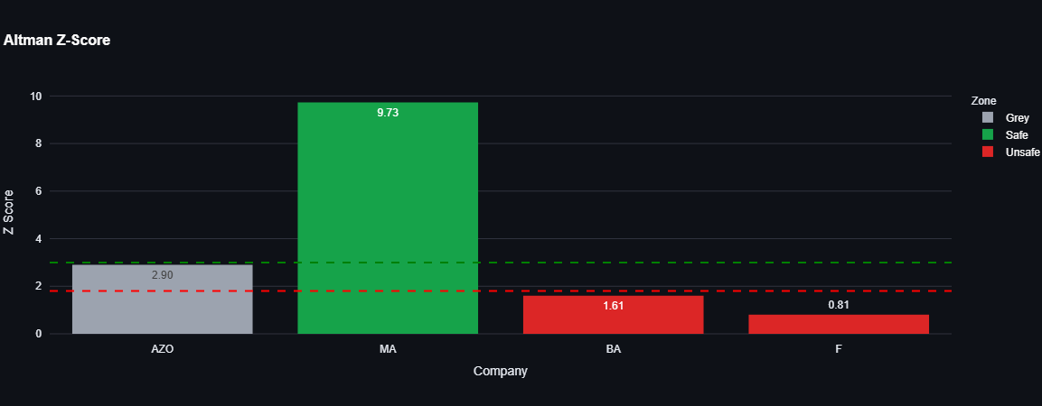
Figure I: Altman Z-Score Results

Interpretation
Mastercard (MA) obtained the highest Z-Score of the portfolio at 9.74, placing it firmly in the Safe Zone. This result is notable given that Mastercard operates as a payment network and not a traditional manufacturer, which is the profile the original 1968 formula was designed for. Its exceptionally high score is largely driven by its asset-light business model: low total assets relative to strong earnings and a very high market capitalization, which inflates the X4 ratio (Market Value of Equity / Total Liabilities) significantly. While the result is directionally correct—Mastercard is indeed a financially sound company—the magnitude of the score should be interpreted with caution given this structural mismatch.
AutoZone (AZO) scored 2.90, placing it at the upper boundary of the Grey Zone. Despite being a large and profitable automotive retail company, its score is compressed by its aggressive share buyback strategy, which has resulted in negative book equity. This makes retained earnings and working capital ratios appear weaker than the company’s actual cash generation would suggest. AutoZone is a case where the Altman model’s accounting-based ratios do not fully reflect the company’s operational health.
Boeing (BA) scored 1.61, placing it in the Unsafe Zone. This result is consistent with the company’s well-documented financial difficulties stemming from production halts, safety crises related to its 737 MAX aircraft, and sustained operating losses. The low score reflects weak EBIT, elevated liabilities, and a deteriorated equity position, all of which are captured by the model’s ratios.
Ford (F) obtained the lowest score of the group at 0.81, also in the Unsafe Zone. Ford carries a substantial debt load primarily linked to its financial services division (Ford Credit), which distorts balance sheet ratios for a manufacturing-oriented model. Low asset turnover and thin operating margins relative to total assets further reduce the score. As with Mastercard, this highlights that sector-specific balance sheet structures can significantly affect the reliability of the Z-Score result.

Merton Model
Published in 1974 by Robert Merton in his paper "On the Pricing of Corporate Debt", the Merton Model approaches credit risk from a fundamentally different perspective than the Altman Z-Score. Rather than relying solely on accounting data, it treats the equity of a company as a call option on its assets, where the strike price is the face value of the company's debt. This means the model is grounded in option pricing theory, specifically the Black-Scholes framework.
The core logic is straightforward: at debt maturity (T), if the value of the company's assets (V) exceeds the value of its debt (D), shareholders retain the difference. If assets fall below the debt value, the company defaults and is handed over to creditors. This payoff structure is identical to that of a call option:
$$E_T = max(A_{T} - L, 0)$$
From this foundation, the model derives two key outputs. First, the Distance to Default (DD), which measures how many standard deviations the company's asset value is from the default threshold:
$$DD= \frac{ln\left(\frac{V}{D}\right) + \left(r +\frac{σ^{2}}{2}\right)⋅ T}{σ ⋅ \sqrt{T}}$$
Where V is the market value of assets, D is the debt value, r is the risk-free interest rate, σ is the asset volatility, and T is the time to maturity.
Second, the Probability of Default (PD), which is derived directly from the DD:
$$PD = 1 - N(DD)$$
Where N is the cumulative standard normal distribution. A lower DD translates directly into a higher probability of default, and vice versa.
One important distinction from Altman is that the Merton Model assumes a lognormal distribution for asset returns rather than a normal distribution, which is more appropriate for financial data since it ensures non-negativity of asset values and better captures the asymmetry and heavy tails observed in financial returns.

Source
The Merton model was implemented using a combination of market and accounting data retrieved through the yfinance library. Specifically, two types of inputs were required for each company. The first is market data: the historical daily closing prices over a one-year window, from which the annualized equity volatility was calculated using logarithmic returns; and the market capitalization, used as a proxy for the market value of equity. The second is balance sheet data: the total debt of the company, which serves as the default point (D) in the model.
For the risk-free interest rate, a fixed value of 3% per annum was used as a reference rate, consistent with the approach suggested in the course material. All four tickers were processed identically: AZO (AutoZone), MA (Mastercard), BA (Boeing), and F (Ford).

Implementation

The Merton model was implemented as a dedicated class that inherits from a shared base class used across all risk models in the system. This design ensures consistency in how company data is accessed and how results are structured throughout the application.
The firm value (V) was approximated as the sum of the market capitalization and total debt, providing a market-informed estimate of the company’s total assets. The default point (D) was set equal to total debt, consistent with the simplified KMV approach discussed in the course. Equity volatility was computed from a year of daily log returns on the stock price and annualized by multiplying by the square root of 252 trading days. This volatility was used directly as a proxy for asset volatility, which represents a simplification of the full iterative Black-Scholes calibration procedure but remains a standard approach in introductory implementations of the model.
With these inputs, the Distance to Default was computed using the formula derived from the log-normal asset dynamics assumption. The Probability of Default was then obtained by applying the complementary cumulative standard normal distribution to the Distance to Default, as specified by the model. A time horizon of one year (T = 1) was assumed for all companies. Tickers for which total debt was zero or equity volatility could not be computed were automatically skipped, with an informational warning logged in the console.

Results

The following table presents the Distance to Default and Probability of Default obtained for each company through the Merton model:

Ticker | Distance to Default (DD) | Probability of Default (PD)
AZO (AutoZone) | 7.64 | <0.01%
MA (Mastercard) | 14.99 | <0.01%
BA (Boeing) | 5.20 | <0.01%
F (Ford) | 1.19 | 11.67%
Table III : Merton Model Default Probabilities Results

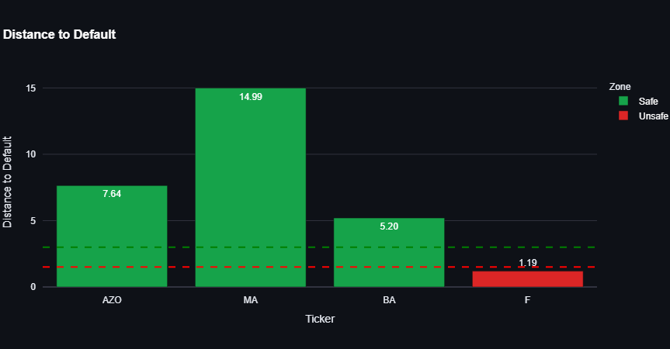
Figure II: Distance to Default bar plot results

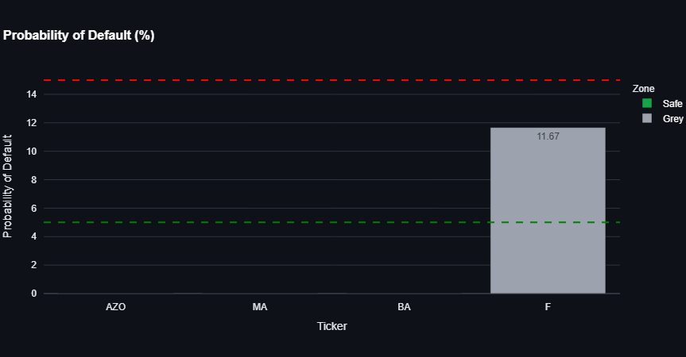
Figure III: Probability of Default bar plot results.

Interpretation

Mastercard (MA) shows the highest Distance to Default in the portfolio at 14.99, with a negligible Probability of Default below 0.01%. This is consistent with its strong market capitalization, low total debt, and relatively modest equity volatility. The model confirms that Mastercard is effectively far from any default scenario under normal market conditions.
AutoZone (AZO) presents a DD of 7.64 and a PD below 0.01%. Despite being classified in the Grey Zone by Altman, the Merton model paints a more favorable picture, reflecting that its market value remains substantially above its debt obligations. This highlights a key conceptual difference between the two models: while Altman relies on accounting ratios that are sensitive to share buyback-driven equity erosion, Merton incorporates market pricing, which better captures investor confidence in the company.
Boeing (BA) has a DD of 5.20 and a PD also below 0.01%, a result that may appear surprisingly low given its ongoing financial challenges. This is partly explained by Boeing’s large market capitalization relative to its debt, which keeps the firm value (V) well above the default point (D), even in the context of significant operational losses. The model suggests that market participants still assign a high value to Boeing’s long-term prospects and asset base, particularly its backlog of aircraft orders, which partially offsets the accounting distress captured by the Z-Score.
Ford (F) is the company with the highest credit risk in the portfolio according to the Merton model, with a DD of just 1.19 and a Probability of Default of 11.67%. This result reflects the combination of a relatively low market capitalization compared to its substantial total debt and a higher equity volatility, which signals greater uncertainty about the future value of its assets. The result is consistent with the Altman Z-Score finding and reinforces the conclusion that Ford presents the weakest credit profile among the four companies analyzed.

Credit Decision

The following table consolidates the results from both models and presents a final credit recommendation for each company. The decision logic combines the Altman Z-Score and the Probability of Default from the Merton model: a company is approved when its Z-Score exceeds 3.0 and its PD is below 5%; it is denied when its Z-Score falls below 1.8 or its PD exceeds 20%; otherwise it is flagged for review.

Ticker | Z-Score | Distance to Default | Probability of Default | Decision
AZO | 2.90 | 7.64 | <0.01% | REVIEW
MA | 9.73 | 14.99 | <0.01% | APPROVE
BA | 1.61 | 5.20 | <0.01% | DENY
F | 0.81 | 1.19 | 11.67% | DENY

Mastercard is the only company in the portfolio that meets both conditions for approval simultaneously: a Z-Score well above 3.0 and a negligible probability of default. AutoZone falls into the review category given that its Z-Score sits in the grey zone, even though the Merton model indicates no meaningful default risk from a market perspective. Boeing and Ford are both denied, with their low Z-Scores driving the decision for Boeing and Ford’s elevated PD of 11.67% serving as an additional disqualifying factor.

Bibliography

- Slay, R. (2023). Altman Z-Score presentation. Instituto Tecnológico y de Estudios Superiores de Occidente (ITESO).

- Slay, R. (2023). Merton model KMV: An introductory overview of the Merton model. Instituto Tecnológico y de Estudios Superiores de Occidente (ITESO).

- Altman, E. I. (2000). Predicting financial distress of companies: Revisiting the Z-Score and ZETA® models. Stern School of Business, New York University.

- Yahoo Finance. (n.d.). Stock market data and financial information. Retrieved February 23, 2026, from https://finance.yahoo.com/

- OpenAI. (2026). ChatGPT [Large language model]. https://chat.openai.com/chat.

